Well another Black Friday is upon us. Once upon a time, when I was younger, I actually viewed Black Friday as a special day to go out and enjoy the hustle and bustle of shopping, to see the Christmas decorations festooning every store, and to but gifts for the loved ones in my family. As I got older and became a bit more cranky, the lust and obsession exhibited by certain people became to weigh me down and cause me to think that Black Friday was to be avoided at every cost. As I’ve gotten even older and more educated about economics, I’ve come back around to liking it but for different reasons.

When viewed objectively, Black Friday is quite an economic miracle. Starting, well… whenever after Thanksgiving, millions of Americans make hundreds of millions if not billions of economic choices in just one day. Stores have to plan and prepare for this bacchanalia of bargain hunting by answering a host of questions. These include:

* which items should be stocked,
* how many of them should be ordered,
* at what price should they be sold,
* how much should be sent on advertising
* and so on.

What is truly remarkable is that no central planner set this organized insanity up. No elite intelligence managed all of the variables for each and every institution. Rather the [invisible hand of capitalism](https://en.wikipedia.org/wiki/Invisible_hand) operates on a massive scale. Every step from discovering and processing raw materials, to designing a product that people want, to the manufacture, shipping, distributing, and retailing of the good, is done by [an intricate, complex web of self-interested decision making](http://commoncents.blogwyrm.com/?p=479).

It is in this way the Black Friday really is a descendent of those first lessons from Thanksgiving: the [ultimately destructive rot of forcing shared work and outcomes](http://commoncents.blogwyrm.com/?p=45) and the need to achieve the [satisfaction of earning your position](http://commoncents.blogwyrm.com/?p=298) by hard work. Stated simply, the creation and participation in a free market.

So, it was with great disappointment that I read the Thanksgiving section (section 3) of James W. Loewen’s book *Lies My Teacher Told Me: Everything Your American History Textbook Got Wrong*.

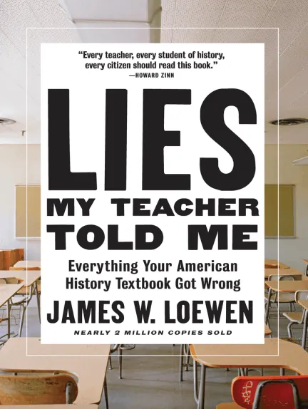

Loewen starts his section with a variety of quotes, obviously intended to set the overall tone about the myth that citizens of the United States entertain about the significance of the Thanksgiving. The three most provocative quotes are:

Considering that virtually none of the standard fare surrounding Thanksgiving contains an ounce of authenticity, historical accuracy, or cross-cultural perception, why is it so apparently ingrained? Is it necessary to the American psyche to perpetually exploit and debase its victims in order to justify its history?

Michael Dorris

European explorers and invaders discovered an inhabited land. Had it been pristine wilderness then, it would possibly be so till for neither the technology not the social organization of Europe in the 16th and 17th centuries had the capacity to maintain, of its own resources, outpost colonies thousands of miles from home.

Francis Jennings

The Europeans were able to conquer America not because of their military genius, or their religious motivation, or their ambition, or their greed, they conquered it by waging unpremeditated biological warfare.

Howard Simpson

Sigh…, where to begin with the material fallacies that abound in each of these arguments. To start with a general observation that each of these quotations address points that have nothing to do with Thanksgiving’s root but rather what each commentator perceives as the modern corruption. It is okay to criticize the modern corruption but it in the spirit of charitable argumentation, each of them should have discussed, at least in passing, the original reason for celebrating Thanksgiving.

Now on to the individual quotes.

Michael Dorris’s quote is distinctly sloppy in failing to define ‘standard fare’. What exactly does he mean? Perhaps the Macy’s day parade or the Black Friday advertisements or even something he sawa on TV. How hard would it have been to say something like ‘… none of the standard fare, which maintains…’? And in what way is celebrating that the Pilgrims eschewed socialism have anything to do with ‘exploiting and debasing America’s victims’?

Francis Jennings’s quote misses the point of the proper roots of Thanksgiving. Yes, on the surface, everything Jennings says is true; Europe could not maintain an outpost colony in the new world. William [Bradford said as much in his writings](http://commoncents.blogwyrm.com/?p=45). He bemoans the fact the colony has to stand on its own two feet while trying to live under the ‘socialist requirement’ levied by the [Company of Merchant Adventures of London](https://en.wikipedia.org/wiki/Company_of_Merchant_Adventurers_of_London), who backed the enterprise. He recognizes the weakness of the arrangement when commenting on the colony’s success in 1622 and early 1623. Finally, Bradford directed the colony to abandon the communal property arrangement in favor of individual rights and obligation. Bradford goes on to say the new arrangement ‘had very good success, for it made all hand very industrious’. His analysis of what went wrong under the communal arrangement was that it was ‘found to breed much confusion and discontent’. It was the abolishment of this terrible communal arrangement and the success adopting individual rights that is the real story of Thanksgiving, a story that Jennings’s quote (and all the others) ignore.

Simpson’s quote is most egregious of the lot. The Pilgrims were neither militaristic nor were they particularly religiously motivated to conquer a new land (they came to the America’s because they had to escape the religious persecution they faced in Europe). And, as Bradford’s narrative attests, they originally had no ambition and no greed under the communal arrangement. All of these points may apply to other colonies at other times, but they are mismatched with Thanksgiving as the subject. Still, I may have been able to overlook these flaws but for the last sentence. It defies common sense to believe anything other than that none of the European settler’s would have been happy to bring disease to the New World; it would counter-productive since it wouldn’t be clear when the disease would turn around and attack them. This claim is particularly strong considering the scaring that Europe bore after the Balck Plague ravaged the land. Also, the [germ theory of disease](https://en.wikipedia.org/wiki/Germ_theory_of_disease) was a discovery of the late 1850s, centuries after the colonization began and at least 80 years after the ratification of the US constitution.

There isn’t much to recommend the rest of the section as well. Loewen engages in a variety of material fallacies of his own, including a equivocal use of the term ‘settler’, an ad hominem attack on WASPs, and an over-emphasis on the diseases that tragically ravaged the Native American population. But, perhaps, the most tragic thing about Loewen’s discussion is not celebrating the triumph of individual rights over collectivism.